interest rate modeling, estimation of the parameters of vasicek model
by
Andrey Ivasiuk
A thesis submitted in partial fulfillment of the requirements for the degree of
Master of Arts in Economics
National University “Kyiv-Mohyla Academy” Economics Education and Research Consortium Master’s Program in Economics
2007
Approved by
Ms. Serhiy Korablin (Head of the State Examination Committee)

Program Authorized
to Offer Degree Master’s Program in Economics, NaUKMA
Date
National University “Kyiv-Mohyla Academy”
Abstract
interest rate modeling, estimation of the parameters of vasicek model
by Andrey Ivasiuk
Head of the State Examination Committee: Mr. Serhiy Korablin,
Economist, National Bank of Ukraine
Vasicek interest model is one of the mostly used in modern finance. It constitutes a basis for derivative pricing theory and finds a sound application in practice. Nevertheless there is a still undeveloped estimation techniques and discussion is going on. In this paper we provided a comparative analysis of the mostly used Euler approximation technique and continuous record based exact ML estimators. We proved asymptotical properties of exact ML estimator and performed a Monte Carlo simulation to investigate convergence peculiarities.

Table of Contents
List of tables………………………………………………………………….(ii)
Acknowledgements……………………………………………………….......(iii)
Chapter 1: Introduction………………………………………………………...1
Chapter 2: Evolution of interest rate modeling…………………………………5
Chapter 3: Vasicek model estimation………………………………………….10
Chapter 4: Prof of consistency and asymptotical unbiasedness……………… 17
Chapter 5: Monte Carlo simulation……………………………………………23
Chapter 6: Conclusions……………………………………………………….26
Bibliography………………………………………………………………….27
Appendix A: Comparative analysis of exact ML and Euler
discretization based estimators… .......………..…………………………….….29
Appendix B: Matlab file for generating Ornstein-Uhlenbeck process……….…30
Appendix C: Matlab file for calculating exact ML estimator…………………...31
Appendix D: Matlab file for calculating ML estimator
based on Euler discretization procedure………………………………………32
List of figures
Number Page
Table 1: Comparative analysis of exact ML and Euler
discretization based estimators……………………………………………..….29
Acknowledgments
I want to thank Andriy Bodnaruk for invisible hand guidance during my work on this paper. The wandoo spirit he shared was essential.
I want to express the separate gratitude to irreplaceable Tom Coupe for his clarification of my contribution.
In addition, grate thanks to Yuriy Evdokimov and Olesya Verchenko for their comments and suggestions.
Very special thanks to Julia Gerasimenko for all support and comprehension provided.

Chapter 1
Introduction
Free capital flow is essential for modern globally integrated economy. It should serve the main economic goal of efficient allocation of scares resources. Short-term risk less interest rate is the basic indicator of global cost of money. Being free of any specific risks it is determined only by the forces of supply and demand at world capital markets and therefore this concept is actually one of the main indicators of the global economy performance. Short term risk free rate constitutes a base for calculation of other rates with different term structures and risk factors. The mostly used rates within the concept are US treasury bills rate and monthly Eurodollar rate. Stochastic models for these rates underline in the assets pricing and derivatives valuations. That’s why economists, econometricians and mathematicians spent much efforts trying to model short-term interest rate. The most developed methodology for asset pricing is based on the theory of stochastic differential equations. The main idea is to use diffusion stochastic process for asset pricing. Diffusion process in general is the process of the following form:

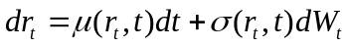 (1)
Here 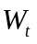is a Brownian motion process, 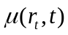 and 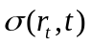are some specified functions. Further engineering deals with the functional forms of  and (Øksendal, 1992). Vasicek was the pioneer in interest rate modeling within this framework. He introduced (1977) the following specification for modeling interest rate:
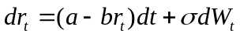 (2)
Here a, b, are positive constants. Under this setup 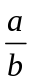 is a long-term equilibrium of short-term rate, b is a pull back speed factor, is so called instantaneous standard deviation of short-term rate. In this model the main principles of interest rate modeling were set for the first time. The main idea is that short-term rate is a subject for non-systematic stochastic shocks but experience a constitutional bias to the long-term equilibrium value. The speed of convergence is proportional to the current deviation from the mean. The proportional relationship between speed convergence and current deviation from long-term equilibrium is determined by the parameter b. Parameter determines the volatility of short-term rate and it is considered to be constant over time. These models defined a fruitful mathematical framework for modern financial economics. Black F. and Scholes M. pioneered in this field (Black F., Scholes M., 1973). Now the asset pricing based on the described models have taken the shape of an independent theory with strong practical applications (Cox, Ross, 1979; Khanna, Madan, 2002; Keppo, Meng, Shive, Sullivan M, 2003). Despite this fact estimation technique for the model is rather undeveloped and discussion remains opened. The most popular approach is to turn to discrete specification. The discretization approach yields a number of applicable estimation concepts (Phillips, Yu, 2007). However there are still problems with this approach. The main pitfall lies in methodological space. The point is that actually we estimate the parameters of another model (Ahangarani, 2004). So the obtained estimates can be treated only as proxies for true parameters. It is shown in practice that these proxies appear not to be precise and are subject to bias. The bias can be partially eliminated and there are some efficient techniques. However in most cases they produce computational problems. It is also shown that estimation under Euler discretization approach leads to the problem of inconsistency (Merton, 1980; Lo, 1988). The ML method, which is generally used, theoretically can be applied in continuous specification. The only requirement is for state variable to be identified. Otherwise it is impossible to constructing likelihood function. For diffusion process specification this problem can be set in terms of partial differential equations and in general can not be solved. So the only numerical methods can be implemented. However in case of Vasicek specification corresponding equation can be solved and we can explicitly write down state variable. So ML method can be applied. However, despite the fact that the estimator is universal remedy, the properties of the ML estimator remain ambiguous. In this paper we investigate so called exact ML continuous estimator considered by Phillips and Yu (2007). The main finding is that this estimator is consistent and asymptotically unbiased.
The paper structure consists of 6 sections. The first one is introduction to the problem; second section provides a brief overview of the evolution of asset pricing modeling and interest rate modeling in particular; the third section provides a discussion on the modern literature on the estimation of parameters of interest rate models based on initial Vasicek specification. In the fourth section we prove the theoretical results: consistency and asymptotical unbiasedness of exact ML estimator. Fifth section reports the result of Monte Carlo simulation which allows comparing asymptotical behavior of Exact ML estimator and ML estimator based on Euler Discretization technique and sixth section provides conclusions.

Chapter 2
evolution of interest rate modeling
The topic of asset pricing modeling was contributed a lot by different theoreticians. Black and Sholes (1973) first introduced the idea of Geometric Brownian motion into the asset pricing. They considered a diffusion driven by stochastic differential equation of the following form:

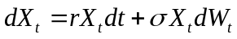, 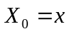, 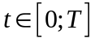; (3)
Whereis a positive deterministic initial condition and 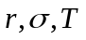are positive constants. The first term of the right hand side of the equation determines the stable growth of the process with the growth rate r. Second term introduces distortion from the growth path in terms of Brownian motion process (Weiner process). We state some basic properties of the Brownian motion process
- is a Gaussian process, i.e. for all 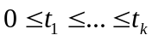the random variable 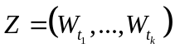 has a (multi)normal distribution.
- 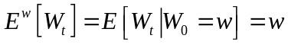for all 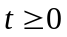. As a rule in financial modeling we assume that we start the pricing dynamics from the equilibrium path, so 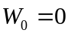. Therefore we have 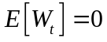 for all.
- 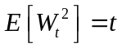, 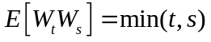
Moreover, 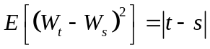 for all .
- has independent increments, i.e.
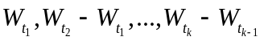are independent for all .
- has a continuous version that means that there exist a process with continuous path such that is indistinguishable from it.
The main finding is that Brownian motion process has stationary independent increments with zero mean (Øksendal, 1992). It is proved that Brownian motion is the unique such process with continuous path.
Black and Sholes solved equation (3) and wrote the explicit formula for the density of the process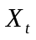. Based on this result they designed a theory of option and other derivatives pricing.
But their model behaved poor in modeling the dynamics of interest rate. The point is that distinguishing feature of the interest rate is its mean reverting property. While there is common for stock prices to experience permanent upward trend, it is not the case for interest rate. This set it apart from other financial prices and demanded other specification for dynamics modeling.

Vasicek (1977) introduced a mathematical model for describing evolution of risk-free short term interest rate by means of Ornstein-Uhlenbeck Gaussian process of the form:
.
The main feature of the model was the instantaneous trend of the process to revert to its long run mean value. Parameter b determines a speed of adjustment and should be positive to ensure convergence. Mean reverting property undermines that this is an equilibrium model. The assumption for the interest rate to be short-term and risk free makes the rate free of impact of such factors as industry risk, corporate governance risk, liquidity risk and others. Actually there is only market risk factor which affects the dynamics. Therefore the model is usually called to be one factor evolution model. That’s why the distortion mechanism is modeled in terms of absolutely stochastic driver with independent stationary increments. The standard deviation parameter determines the volatility of interest rate.
This normal mean reverting process determines a benchmark for discount bond pricing providing theoreticians with a sharp tool for valuing futures, options and other contingent claims.
The pitfall of the model was the theoretical possibility of the interest rate to become negative. To overcome the problem Cox, Ingersol and Ross (1985) introduced their model which specified the interest rate that follows stochastic differential equation
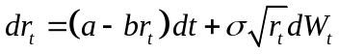.
The underlying idea is following: when interest rate comes close to zero its standard deviation converges to zero also. So the volatility takes minor effect on the dynamics. It becomes to be driven mainly by the mean reverting term. The mean reversion incorporated the same way as in Vasicek model and it pushes interest rate up to the long run equilibrium.
Chan K.C. (1992) generalized this approach introducing two models which are actually nested versions of Cox, Ingersoll & Ross specifications. His proposition was to allow interest rate to follow stochastic differential equations of the type:
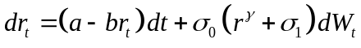 and
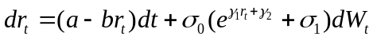
These models use classical mean reverting mechanism but equipped with different and rather complex volatility structures that makes them more flexible. However in contrast to first three models the estimation technique for the last two is not well developed and even in case of discretization leads to computational difficulties. The model selection problem also remains unsolved.
Hull and White (1990) tried to generalize Vasicek model in another way. They let model parameters a, b and to be time depending functions. Thus the equation for interest rate in general takes the form:
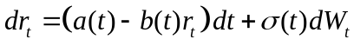.
However this general specification leaves practitioners an ambiguity about which parameters to treat as time dependant and which not. The mostly used approach is to leave b and constant but consider a to depend on t. This actually means that the equilibrium value of interest rate changes with time. It allows adjusting the model to the seasonal and other cyclical patterns which are peculiar to some rates. Typically 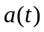 is calculated from the initial yield curve describing the current term structure of interest rates while b is to be entered as an input.

Chapter 3
Vasicek model estimation
Since Vasicek first introduced his model of short term risk free interest rate the discussion of the parameters estimation continues. In this section we will discuss the most applied approaches following the literature on the relevant topics.
Kimiaki Aonuma (1997) used Vasicek type model for Credit Default Swap valuation. He used a version of method of moments based on the idea of marginal distribution. The main idea is that in the limit we can state:
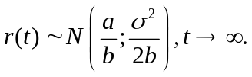 (4)
He presumed this homogenization to hold universally in t. Than having the values of the process in n points in time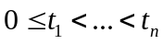we can write down the standard estimates of the parameters of the normal distribution:
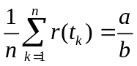; (5)
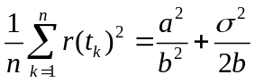. (6)
The method is used for estimation of speed of adjustment and volatility parameters b and given the mean value. Further it turns simply to solve the following minimization problem: let
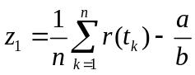;
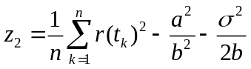.
minimize 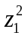,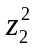with respect to b and .
While the method is very simple to use there is problem with validity of the method. First of all when writing equations (5) and (6) we automatically undermine that values of the rate driving process are independent in the fixed moments of time that is incorrect. The values of the process in Vasicek model at different time moments are correlated. Authors analyzed the scope of the error performing Monte Carlo simulation for different true values of the parameters.
More common approach uses Euler Discretization technique. Ahangarani P.M. (2004) used the following discrete form approximation
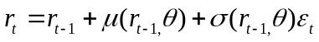 (7)
Hhere 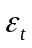is a Gaussian white noise. Than the maximum likelihood technique can be applied for estimation of the model (7). The maximum likelihood estimator is defined as
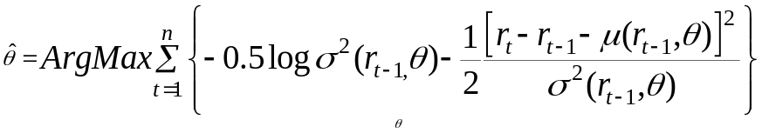
The problem with this methodology is that we actually estimate the parameters of the misspecified model but not of the original one. It leads to an asymptotic bias. There is a concept of indirect inference which uses simulation under initial model to correct for this bias. Here the main idea is to use the second Euler discretization of the following type:
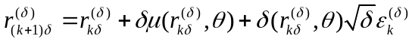;
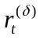, 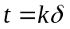.
Here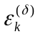, k varying is a Gaussian white noise. Actually we defined a discrete process 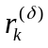using a much smaller time unit and obtain the simulated time path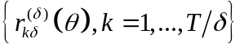. The indirect inference approach includes three steps. First, the estimation of the parameter from the initial model on the bases on some fixed discrete number of observations. Second step implies simulating a second discretization and estimation parameters of the modeled time path. At this step ML technique can be used just the same way as described above: 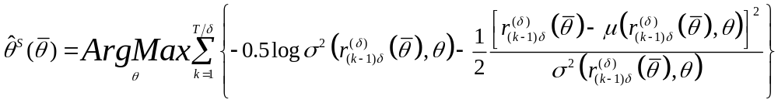
Third step is a calibration procedure:
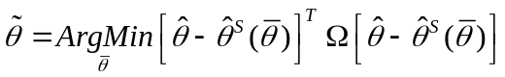.
Gourieroux and Monfort (1996) have shown that for T sufficiently large the choice of can be arbitrary. So it is reasonable simply to take the identity matrix to simplify calculations. Nevertheless the approach consists of two step nested optimization procedure that bring computational difficulties. The method provides a stochastic simulation of the time path to fill up the gaps between the observations of original process. So the main problem of misspecification remains the same. However method can be useful in case of pure samples.
Duffee and Stanton (2004) provided some generalization of the methods described above, introduced an efficient method of moments and performed a comparative analysis. They concluded that in general ML procedure yields highly biased estimates. However the presence of cross-sectional information reduces the bias for the estimates of both volatility and speed of adjustment. Another finding is that in case of small samples ML method performs better than Efficient Method of moments, despite the common asymptotical properties. The speed of convergence to asymptotical type behavior is higher for ML estimators.
There is a common idea which goes through the whole literature on the topic: to approximate the original continuous process with the discrete analog. Than the estimates of parameters are built for this proxy-process and are treated to be the estimates of parameters of the original one. The idea itself is reasonable in view of the fact that the historical data as a rule is of discrete type. But in this case we actually deal with the misspecification problem so the properties of so calculated estimates are subject for further investigation. There are at least two questions which are to be discussed in this view. First of all whether the discrete approximation is adequate? The point is that continuous modeling is based on the well investigated Brownian motion process. The properties of this mathematical design on the one hand are suitable for describing volatility of financial assets prices and on the other hand let the large space for developing the derivative pricing methods. Modern financial mathematics made much progress in this field both in theoretical and applied focuses. As a result a sophisticated theory of option prices and optimal portfolio control is elaborated. That’s why the proxy process is a subject for tradeoff between the estimation simplicity and the ability to capture the implied dynamic pattern of the data as the original diffusion process do. The second point is the accuracy of the estimates of the proxy process. There is still little progress in building effective estimates for parameters of simplified processes. In particular, Euler approximation being the most developed approach yields parameters estimators which are biased (Ahangarani, 2004) and inconsistent (Merton, 1980; Lo, 1988). It means that even when the sample size becomes large the bias remains significant.
There is an alternative approach for estimation of parameters of the model. This is so called exact Maximum Likelihood estimator based on the original specification and continuous record of the process time path. The main complexity of this approach is that in general it is impossible to write down an explicit expression for likelihood function for diffusion process specified in terms of equation (1). But it can be done for Ornstein-Uhlenbeck process so the estimators themselves can be written in explicit form. Comparative analysis based on simulation shows that in relatively small samples this estimator performs similar to estimators yielded in discretization approaches (Phillips, Yu, 2007). They concluded that exact ML estimator still remains biased. The question is whether the problem of bias can be solved in terms of asymptotic properties. The main objective of this paper is to answer the question.
Exact Maximum Likelihood estimators themselves can be easily derived from the first order conditions for corresponding Likelihood function and looks like:
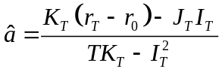,
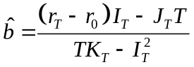.
Where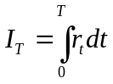,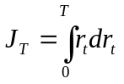,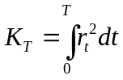. We will comment on the derivation in the next section. In this paper we prove that given estimators are consistent and asymptotically unbiased. The intuition on the result is strongly backed up by Lanska (1979), who showed that Maximum Likelihood estimator of the parameter of continuous-time Markov process, which is described by non-linear stochastic differential equation, is consistent in case of one parameter which takes value from open or compact set of real numbers. Thus we extended Lanska`s result for Ornstein-Uhlenbeck Gaussian process.
Note that in this case the estimators use as an input a continuous record of the interest rate dynamic time path. This of course hides a trap because the continuous time path actually a theoretical concept. The point is that any data in principle collected in discrete way, so there is also a shortcoming here. However this lack is of rather acceptable consequences. The point is that on the one hand there are inverse numerical procedures for recovering continuous time path on the basis of fixed point’s values for both the mathematical and computational tools are well developed. The simplest way is to treat the data as a line segment continuous function. There is also well developed methodology based on cubic spline functions. On the other hand we have transmitted the problem from the statistical field, so now it is a subject for improvement of up-to-date reporting systems and numerical procedures which are developing in hectic pace.

Chapter 4
Proof of consistency and asymptotical unbiasedness
Consider original stochastic differential equation which drives the diffusion of Vasicek interest rate model.
. . (8)
Here 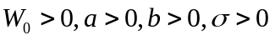. If the sample time path of the process is given, we can calculate a quadric variation of the process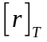. It provides a perfect estimator of diffusion term:
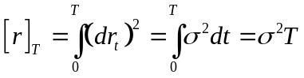.
Thus we can effectively assume parameter to be known (Phillips, Yu, 2007). We will estimate the parameter 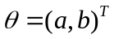by Maximum Likelihood given the true value of volatility parameter. The log-likelihood function can be explicitly written for the process and has the form (Heyde, 1997):
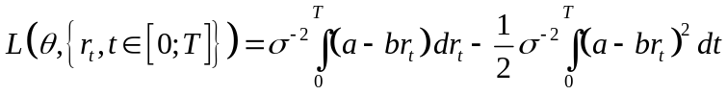.
Write down the derivatives:
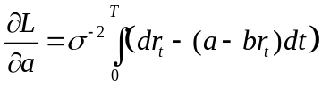,
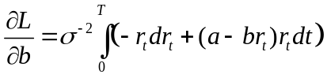.
Equating to zero obtain the expression for the exact Maximum Likelihood estimators:
,
.
Where ,, .

Let’s write down an explicit solution of the equation (8) in the form: 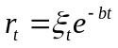.
As satisfies (8) we can write down:
,
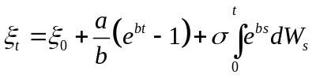.
Øksendal (1992) provided the result of existence and uniqueness of the solution of linear stochastic differential equation. It let us state:
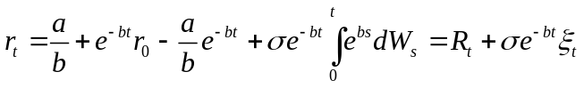,
Where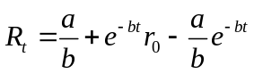, 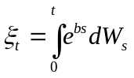. Note that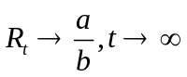.
Let’s formulate standard result from diffusion process theory which we will use later.
Lemma 1
Let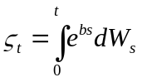, where is a Brownian motion process. Than
i. 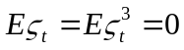;
ii. 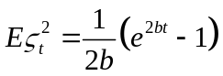;
iii. 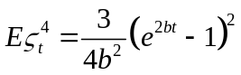, ;
iv. 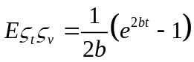, 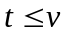;
v. 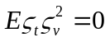,,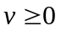;
vi. 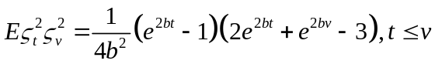.
Let’s find more convenient form of the integrals 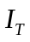and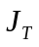. Integrate initial equation (8) on the segment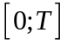:
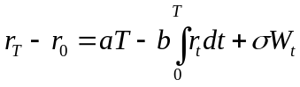,
Obtain an expression for:
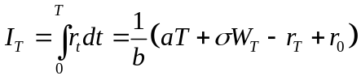.
From ITO formula we obtain:
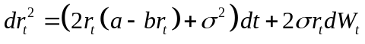,
From the other hand equation (8) yields:
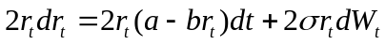.
Equating proper terms obtain: 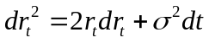, that gives:
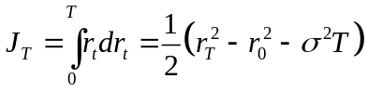.
Lemma1 and these results let us easily calculate moments of the process.
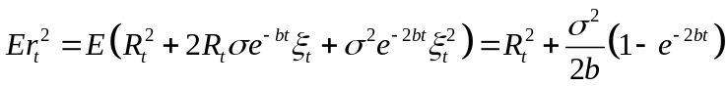, (9)
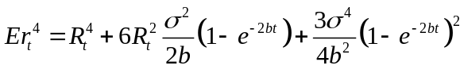, (10)
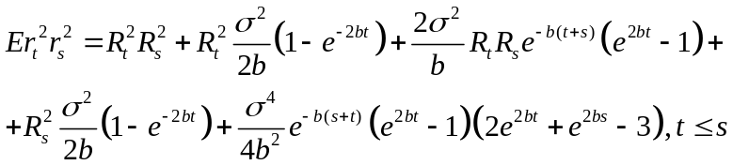 (11)
These results will be useful for checking ML estimators for asymptotic properties.
First we investigate asymptotic behavior of integrals,and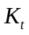 .
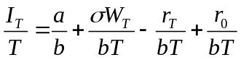.
It is a standard fact that 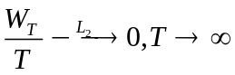(Øksendal, 1992). Equation (9) together with properties of the function 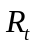 gives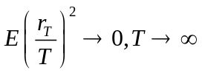, so we have 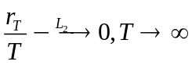. Finally 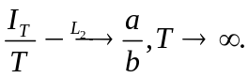 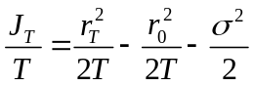,
From (10) we have 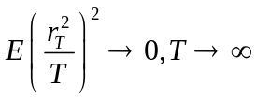that gives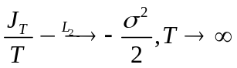.
Estimation of is a bit tricky. 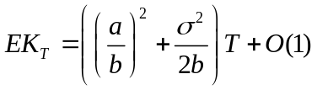,
That gives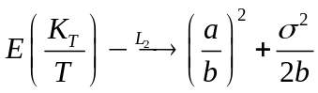.
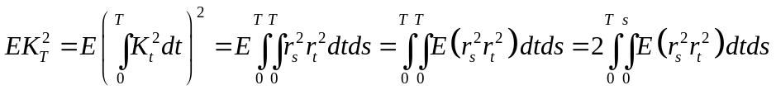.
Plugging an expression for 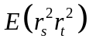from (11), obtain
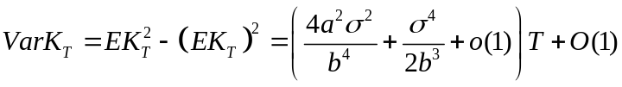,
and 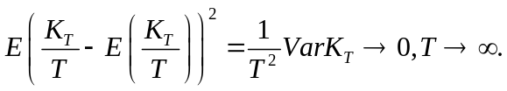
It gives 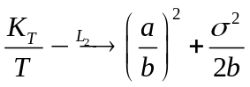.
Finally we can state the asymptotical properties of estimators and.
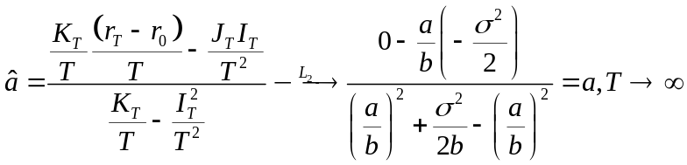,
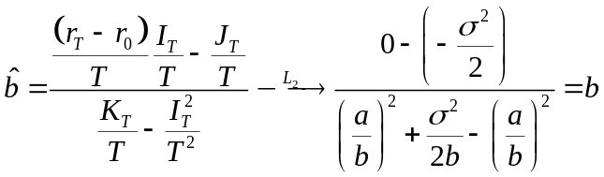,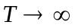.
Since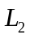-convergence guaranties both -convergence and P-convergence, we have that ML exact estimators are consistent and asymptotically unbiased.

Chapter 5
Monte carlo simulation
In this section we review the results of comparative analysis by means of Monte Carlo experiment. The objective of the experiment was to investigate sensitivity of the properties of two alternative estimators to the sample size. The problem is of grate interest in view of the discussion on implementability of the estimators which are based on continuous record. The point is that statistical data is available in discrete form only. So the integrals can not be computed precisely but only as a Darboux sums. As the existence of the integral construction is proved and originally it is defined as a Darboux sum margin we have no distortions in asymptotic properties. It should be mentioned that in case of continuous estimators sample size can be treated either as an order of Darboux sum, and therefore the precision of integrals approximation, or as the length of time path observed. As both approaches are of the same nature precisely to the variance scale, one simulation series covers both two and we will refer to it as to sample size problem. We replicated 100 hundred realizations of the Ornstein-Uhlenbeck Gaussian process time paths with parameters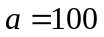,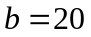,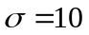, 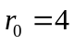and normalized observed time interval. Three sample sizes with numbers of observations 1000, 10000 and 100000 correspondingly were considered. Table1 reports the results of procedure. For each sample size the result includes mean value of the estimator, variance and quadric deviation from the true value of the parameter. Additionally we include third column for the estimator of the mean value of the process calculated as a simple ratio of the corresponding estimators for parameters a and b.
Following conclusions can be drawn form the table. First, in small samples (about 1000 observations) exact estimator shows a downward bias of about 40% and wild deviation statistics with respect to both parameters. This fact is consistent with the continuous nature of the estimators which can not be captured under small sample size. At the same time Euler discretization approach produces acceptable results with standard deviations of about 10%. Nevertheless both approaches appear to be effective in estimating process mean value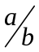.
Second, for sample size of 10000 observations exact estimator performs better however the difference is not significant. Euler Discretization yields an upward bias which produces minor effect on estimator properties. As the sample increases this bias becomes more evident however the scale of the overall bias diminishes. Third, we can see that Euler discretization estimator shows the convergence in means to the true values of parameters which is not consistent with Merton (1980) and Lo (1988) who concluded inconsistency of the estimator. While Monte Carlo experiment results do not allow us to make any critical conclusions, they indicate the field where more accurate theoretical investigation may be fruitful. Additionally we can see that both estimators perform similarly in terms of quadric deviations, which is another measure of goodness of the estimators. All these facts let us conclude that for sample size greater than 1000 exact estimator is preferable.

Chapter 6
conclusions
This paper provides an analysis on estimation techniques for stochastic model of risk free interest rate dynamic proposed by Vasicek. As the model itself very popular in applied finance the estimation procedures constitutes a basis for fruitful discussion. We contrast the mostly used discretization technique with the continuous record based exact ML estimators and provide a comparative analysis. While both estimators are known to be biased the core question was about the asymptotic properties. It appeared that exact estimator has an advantage in terms of consistency and asymptotical unbiasedness that is not the case for discretization technique. We provided a formal prove of consistency and asymptotical unbiasedness and performed a Monte Carlo simulation in order to capture the scale of distortions caused by discretization and speed of convergence for exact estimator. The main conclusion is that being continuous type technique exact estimator is inapplicable when sample size is low. However for sample sizes grater than 10000 exact estimator becomes preferable to the discretization based technique.
bibliography

Ahangarani P.M., 2004, An Empirical Estimation and Model Selection of the Short-Term Interest Rates, University of Southern California, Economics Department

Aonuma K., Nakagawa H., 1997, Valuation of Credit Default Swap and Parameter Estimation for Vasicek-type Hazard Rate Model, The Bank of Tokyo-Mitsubishi, Ltd. and the University of Tokyo

Benninga S., Wiener Z., 1998, Term Structure of Interest Rates, Mathematica in Education and Research, Vol. 7 No. 2

Black, F. and Scholes, 1973, Pricing of Options and Corporate Liabilities, Journal of Political Economics, 81, 637-54

Brigo D., Mercurio F., 2000, Discrete Time vs Continuous Time Stock-price Dynamics and Implications for Option Pricing, Product and Business Development Group Banca IMI,
San Paolo IMI Group

Cox J. C., Ross S. A., Rubinstein M., 1979, Option Pricing: A Simplified Approach, Massachusetts Institute of Technology, Cambridge, USA

Duffee G.R., Stanton R.H., 2004, Estimation of Dynamic Term Structure Models, Haas School of Business, U.C. Berkeley

Gerber H.U., Shiu E. S.W., 1993, Martingale Approach to Perpetual American Options, University de Lausanne, Switzerland, The University of Iowa, U.S.A.

Heyde C.C., 1997, Quasi-likelihood and its application: a general approach to optimal parameter estimation, Springer-Verlag, New York

Jun Yu, Phillips P.C.B. 2001, Gaussian Estimation of Continuous Time Models of the Short Term Interest Rate, Cowles foundation discussion paper №1309, Yale University

Khanna A., Madan D.P., 2002, Understanding Option Prices, Robert H. Smith School of Business, Van Munching Hall, University of Maryland

Lánska, V., 1979, Minimum contrast estimation in diffusion processes. Journal of Applied Probability, 16, 65.75.

Merton R.C., 1980, On Estimating the Expected Return on the Market, Massachusetts Institute of Technology, Cambridge, USA

Øksendal B., 1992, Stochastic Differential Equations, Springer-Verlag, New York

Philips P., Jun Yu, 2007, Maximum Likelihood and Gaussian Estimation of Continuous Time Models in Finance, Cowels Foundation Discussion Paper №1597, Yale University

Vasicek, O., 1977, An equilibrium characterization of the term structure, Journal of Financial Economics, 5, 177.186.

Appendix A
COMPARATIVE ANALYSIS OF EXACT ML AND EULER DISCRETIZATION BASED ESTIMATORS
Table 1
Comparative analysis of Exact ML and Euler Discretization based estimators
sample size |  | n=1000 |  |  | n=10000 |  |  | n=100000
 |  | a | b | a/b | a | b | a/b | a | b | a/b
Exact ML | mean | 63,4525 | 12,6274 | 5,0278 | 98,6121 | 19,7111 | 5,0028 | 100,0347 | 20,0074 | 4,9999
Exact ML | variance | 78,3816 | 3,2677 | 0,0006 | 10,1305 | 0,3962 | 0,0000 | 1,5375 | 0,0626 | 0,0000
Exact ML | quadric deviation | 1414,1043 | 57,6223 | 0,0013 | 12,0569 | 0,4796 | 0,0000 | 1,5387 | 0,0626 | 0,0000
Euler discretization | mean | 100,8507 | 20,1835 | 4,9975 | 101,7591 | 20,3468 | 5,0012 | 100,4630 | 20,0940 | 4,9997
Euler discretization | variance | 70,2208 | 2,9314 | 0,0002 | 10,5015 | 0,4157 | 0,0000 | 1,6383 | 0,0667 | 0,0000
Euler discretization | quadric deviation | 70,9445 | 2,9650 | 0,0003 | 13,5958 | 0,5360 | 0,0000 | 1,8526 | 0,0755 | 0,0000

Appendix B
MATLAB FILE FOR GENERATING ORNSTEIN-UHLENBECK PROCESS
%function gen = Generate_variables%

power = 4
n = 10^power;

tic
% =====================================================
x = normrnd(0,1/n,n,1); % normal random variable
% Setting parameters for Olsten-Uhlenbeck process:
% =====================================================

b = 20;
a = 100;
sigma = 10;
r_0 = 4;

% Generating Ornstein-Uhlenbeck process:
% =====================================================
i = 0;
y = zeros(n,1);
for i = 1:n
y(i) = sigma*exp(b*i/n)*x(i);
end

z = ones(n,1); % Ornstein-Uhlenbeck auxiliary vector
i = 0;
for i = 1:n
z_aux = y(1:i,1); % auxiliary vector
z(i) = sum(z_aux);
end

r = zeros(n,1);
i = 0;
for i = 1:n
r(i) = a/b + exp(-b*i/n)*r_0 - a/b*exp(-b*i/n) + exp(-b*i/n)*z(i);
end

t = toc
% figure
% plot (y);
% title('y i')
%
% figure
% plot (z);
% title('z i')

figure
plot (r);
title('r i')

save data r % saving generated process in Matlab format
Appendix C
MATLAB FILE FOR CALCULATING EXACT ML ESTIMATOR
function est = Estimator_1(r);

load data % loading saved data

% Estimating parematers:
% ===================================================================

[T, M] = size(r);

T_const = 1;
I = sum(r)/T;

% sigma_sq = 10000;
diff = r(2:T,1)-r(1:T-1,1); % we take vector of elements from 2nd to last
diff_aug = [r(1)- 4; diff];
J = sum(r.*diff_aug);

K = sum(r.^2)/T; % we first square each element in r, and then find the sum of vector

a_est = (K*(r(T)-r(1)) - J*I)/(T_const*K-I^2);
b_est = (I*(r(T)-r(1)) - J*T_const)/(T_const*K-I^2);

est = [b_est; a_est];
Appendix D
MATLAB FILE FOR CALCULATING ML ESTIMATOR BASED ON EULER DISCRETIZATION PROCEDURE
function est = Estimator_2(r);

load data

[T, M] = size (r);
T_const = 1;
r_prev = r(1:T-1,1);
r_prev = [4; r_prev];

alfa = sum(r-r_prev);
beta = sum(r_prev)/T;
gamma = sum((r-r_prev).*r_prev)/T;
delta = sum(r_prev)/(T^2);
lamda = sum(r_prev.^2)/(T^2);

b_est = (delta*alfa - gamma)/(lamda - delta*beta);
a_est = (alfa + b_est*beta);

est = [b_est; a_est];

